**Capacity Reservations:**

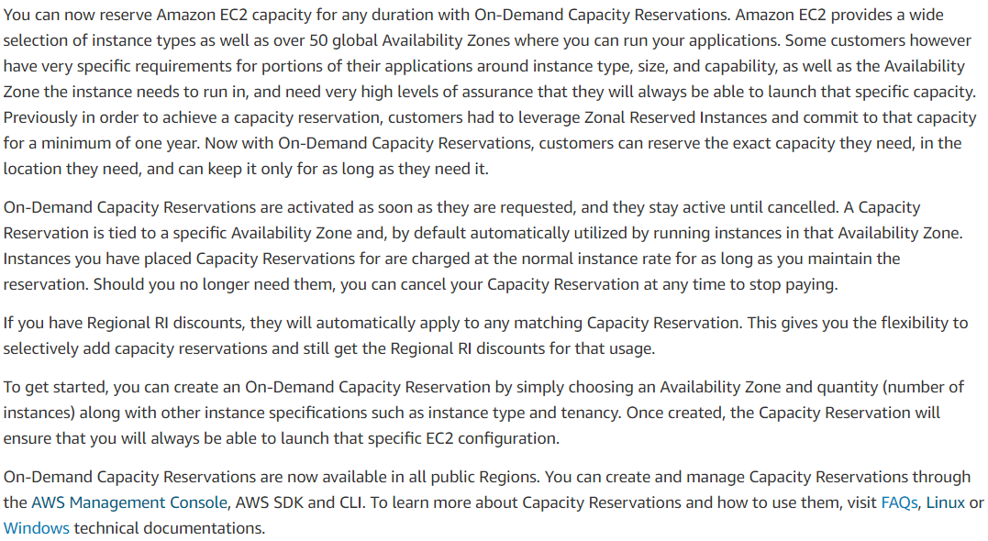

**Differences Between Capacity Reservations, Reserved Instances, and Savings Plans:**

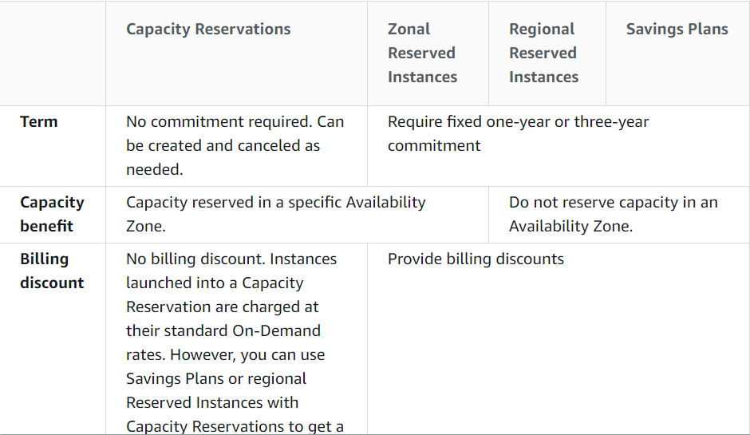

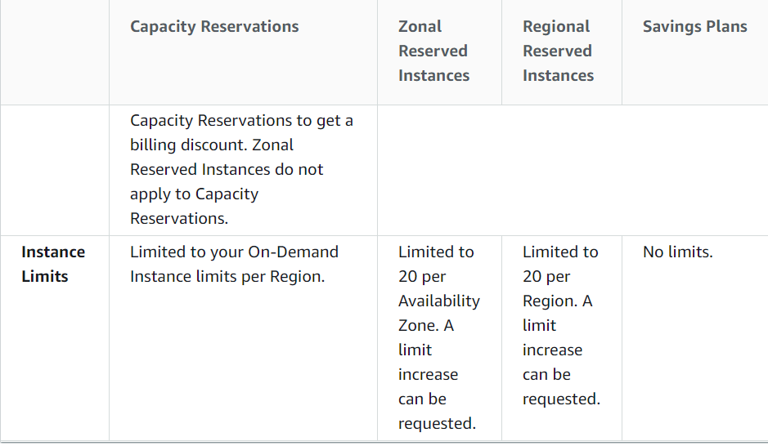

**Capacity reservation limits and restrictions:**

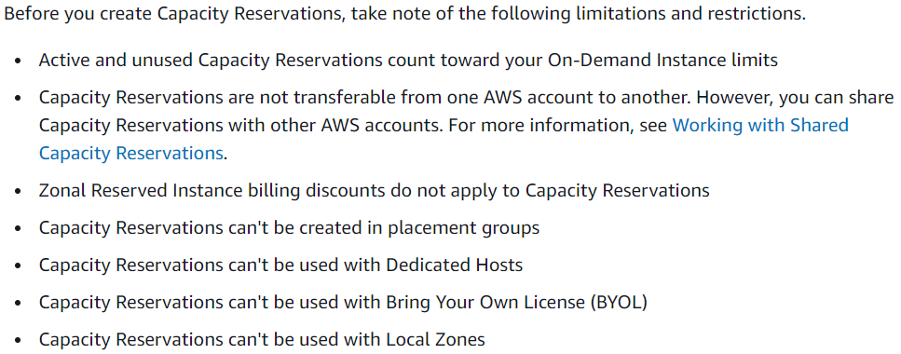

We can also share the capacity reservations between the AWS accounts.

